****Packet Tracer - Configuring IPv6 ACLs****

1. Topology

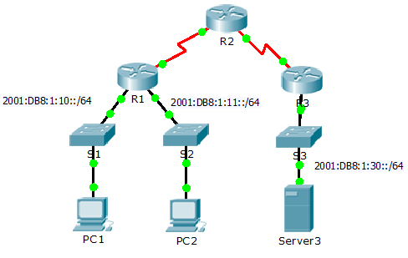

1. Addressing Table

|  |  |  |  |
| --- | --- | --- | --- |
| Device | Interface | IPv6 Address/Prefix | Default Gateway |
| Server3 | NIC | 2001:DB8:1:30::30/64 | FE80::30 |

1. Objectives

Part 1: Configure, Apply, and Verify an IPv6 ACL

Part 2: Configure, Apply, and Verify a Second IPv6 ACL

1. Configure, Apply, and Verify an IPv6 ACL

Logs indicate that a computer on the 2001:DB8:1:11::0/64 network is repeatedly refreshing their web page causing a Denial-of-Service (DoS) attack against **Server3**. Until the client can be identified and cleaned, you must block HTTP and HTTPS access to that network with an access list.

* 1. Configure an ACL that will block HTTP and HTTPS access.

Configure an ACL named **BLOCK_HTTP** on **R1** with the following statements.

* + 1. Block HTTP and HTTPS traffic from reaching **Server3**.

R1(config)# **deny tcp any host 2001:DB8:1:30::30 eq www**

R1(config)# **deny tcp any host 2001:DB8:1:30::30 eq 443**

* + 1. Allow all other IPv6 traffic to pass.
  1. Apply the ACL to the correct interface.

Apply the ACL on the interface closest the source of the traffic to be blocked.

R1(config-if)# **ipv6 traffic-filter BLOCK_HTTP in**

* 1. Verify the ACL implementation.

Verify the ACL is operating as intended by conducting the following tests:

* Open the **web browser** of **PC1** to http://2001:DB8:1:30::30 or https://2001:DB8:1:30::30. The website should appear.
* Open the **web browser** of **PC2** to http://2001:DB8:1:30::30 or https://2001:DB8:1:30::30. The website should be blocked
* Ping from **PC2** to 2001:DB8:1:30::30. The ping should be successful.

1. Configure, Apply, and Verify a Second IPv6 ACL

The logs now indicate that your server is receiving pings from many different IPv6 addresses in a Distributed Denial of Service (DDoS) attack. You must filter ICMP ping requests to your server.

* 1. Create an access list to block ICMP.

Configure an ACL named **BLOCK_ICMP** on **R3** with the following statements:

* + 1. Block all ICMP traffic from any hosts to any destination.
    2. Allow all other IPv6 traffic to pass.
  1. Apply the ACL to the correct interface.

In this case, ICMP traffic can come from any source. To ensure that ICMP traffic is blocked regardless of its source or changes that occur to the network topology, apply the ACL closest to the destination.

* 1. Verify that the proper access list functions.
     1. Ping from **PC2** to 2001:DB8:1:30::30. The ping should fail.
     2. Ping from **PC1** to 2001:DB8:1:30::30. The ping should fail.

Open the **web browser** of **PC1** to http://2001:DB8:1:30::30 or https://2001:DB8:1:30::30. The website should display.